**E-R Diagram**

**E-R Diagram**



**CLASS DIAGRAM**

Class diagrams describe the structure of the system in terms of classes and objects. The servlet api class diagram will be as follows.

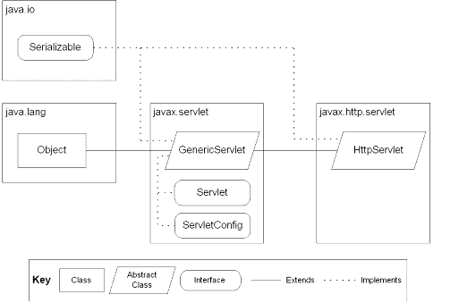

JSP: Implicit Objects

**Use Case Diagrams**

**UML Diagrams**

**Unified Modeling Language**:

The Unified Modeling Language allows the software engineer to express an analysis model using the modeling notation that is governed by a set of syntactic semantic and pragmatic rules.

A UML system is represented using five different views that describe the system from distinctly different perspective. Each view is defined by a set of diagram, which is as follows.

* + User Model View
    1. This view represents the system from the users perspective.
    2. The analysis representation describes a usage scenario from the end-users perspective.
  + Structural model view
    1. In this model the data and functionality are arrived from inside the system.
    2. This model view models the static structures.
* Behavioral Model View

It represents the dynamic of behavioral as parts of the system, depicting the interactions of collection between various structural elements described in the user model and structural model view.

* Implementation Model View

In this the structural and behavioral as parts of the system are represented as they are to be built.

* Environmental Model View

In this the structural and behavioral aspects of the environment in which the system is to be implemented are represented.

UML is specifically constructed through two different domains they are:

* UML Analysis modeling, this focuses on the user model and structural model views of the system.
* UML design modeling, which focuses on the behavioral modeling, implementation modeling and environmental model views.

Use case Diagrams represent the functionality of the system from a user’s point of view. Use cases are used during requirements elicitation and analysis to represent the functionality of the system. Use cases focus on the behavior of the system from external point of view.

Actors are external entities that interact with the system. Examples of actors include users like administrator, bank customer …etc., or another system like central database.

**Use Case Diagrams**

1. **System Use Case Diagram**

System

**Online Job Portal**

**JobProvider**

**JobSeeker**

**NormalUser**

1. **Normal User Use Case Diagram**



1. **Job Seeker Use Case Diagram**



1. **Job Provider Use Case Diagram**



**Sequence Diagrams**

**Sequence Diagrams**

1. **Job Seeker Sequence Diagram**



1. **Job Provider Sequence Diagram**



**Context Analysis Diagram**

Job Provider

Job Seeker

Online Test

Login

Display the Screen based on the login

**FLOW DIAGRAM**

**Search Engine for the job portal FLOW DIAGRAM**

**Login**

Provider

No

Yes

Yes

New User

Option to Create New User

Login Form for User Validation

Message with Re-login Form

If Job Provider

Or

Job Seeker

Job Provider Specific Page with all Options

Job Seeker Specific Page with All Options

No

# Tree Structure Diagrams

Tree Structure

Jobs

View All Jobs

Delete Jobs

Update Jobs

Post Jobs

Job Provider

Resume Processing

Feed Back

Logout

Test Queries

Jobs

Search Engine

Online Test

Job Provider

Job Seeker

Search Job

Online Test Queries

View All Queries

Delete Queries

Update Queries

Add Queries

**State Diagram For Login Validation Module**

Job Seekers

Post Resume

Update Resume

View All Jobs

Feedback to Job Providers

Logout

Personal Information

Inbox

Update Personal Information

Update Password Information

View All Information

Resume Processing

View All Resumes

Send Message to Job Seekers for Online Test

Delete Unnecessary Data

**State Diagram for Requirements Module**

**Select Requirements**

**State Diagram for Resume Processing Module**

**Select Resume Processing**

Select Candidate‘s Name

Select Job Code

Select Process

Invalid

Submit

Short List for Test

Short List

For

Do: Display Req. Menu

Do: Display List of Candidates Selected for Test

Do: Display List of Candidates Selected for Interview

Do: Display Resume Processing Menu

Do: Display Job Codes to Process

Do: Display

Candidates applied for

that Job Code

Do: Display Candidates Details & Input

Do: Validate

Do: Display Error

Do: Display Message

Process

Start Up

**State Diagram for Online Test Queries Module**

**Select Questions**

**State Diagram for Authentication Module**

**Select Authentication**

Submit

Invalid

Valid

Submit

Update

View

Modify

Add New

Start Up

Do: Display Authentication Options

Do: Display Input Screen

Do: Display Message

Do: Validate Input Data

Do: Display Error Message

Do: Display Authentication List

Do: Display Options

Do: Display Updating Screen

Do: Display Message

Do: Validate Input Data

Do: Display Error Message

Invalid

### Authentication

**Activity Diagrams**

**Activity Diagram for Checking Authorization**

Authorization Checking

Authorized

Unauthorized

Display Home Page

Display Error Page

**Activity Diagram for Resume Processing**

Fails

Get Through

Display Opportunities

Application for Job

Application Processing

Selects

Rejects

Online Test

Removing Application

Interview

**Activity Diagram for On Line Test**

Fails

Get Through

Authorized

Unauthorized

Checking Authorization

Online Exam

Call for Interview

Reporting for Unqualified

Interview

Error Report

**Activity Diagram for Selecting Candidates for On Line Test & Interview**

Fails

Get Through

Qualified

Unqualified

Edit Opportunities

Select Candidates for Online Test

Send Authorization for Online Test

Report for

Un-qualification

Monitor Online Test

Process the Result

Conducting Interview

Unqualified Reporting

**Component Diagram**

**Component Diagram :**

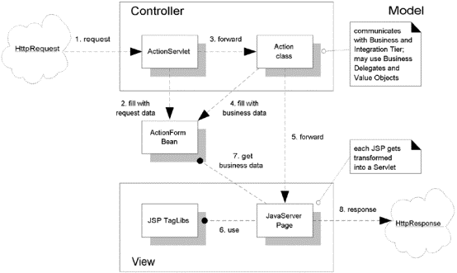

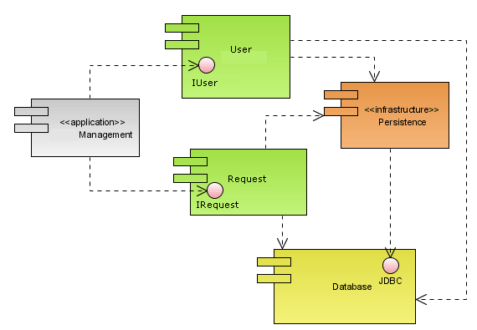

**Deployment Diagram**

**Deployment Diagram:**

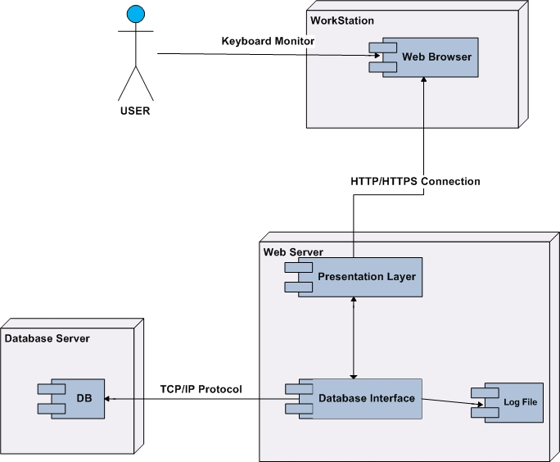

**Data Dictionary**

**Data Dictionary**

**FEED_BACK**



**JOB_PRO**

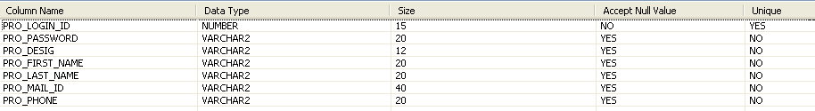

**JOB_REQU**

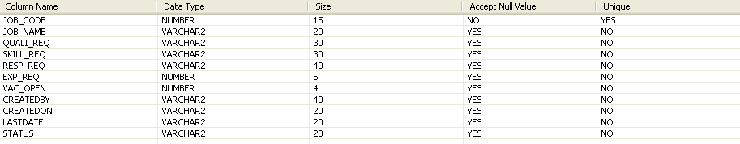

**ONLINE_TESTLOGIN**



**SEEK_ADD**

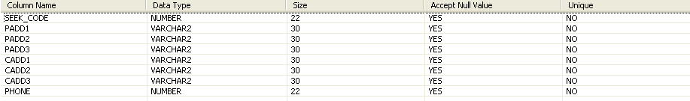

**SEEK_EDU**

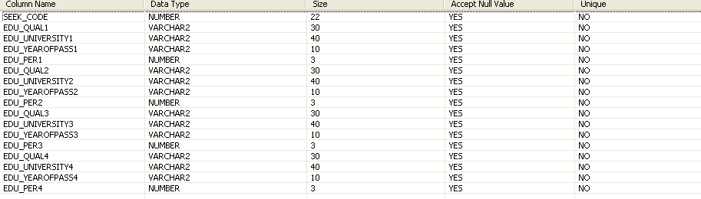

**SEEK_LOGIN**



**SEEK_PER**

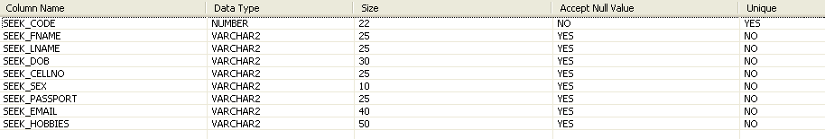

**SEEK_RESUME**

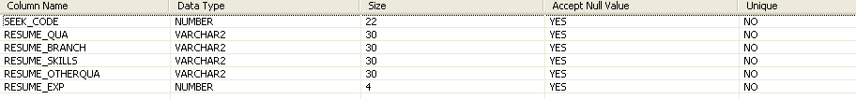

**SEEK_RESUMEUPDATE**



**TEST_QUERIES**

